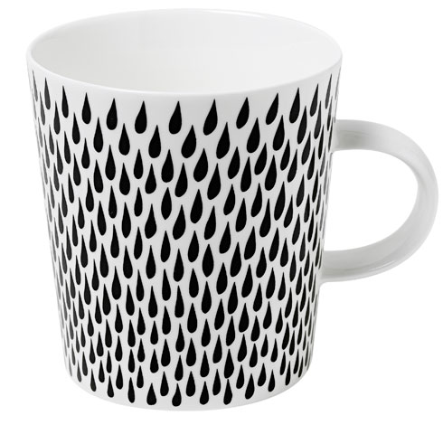

Start your day with your favourite beverage in these classy &colourful ceramic mugs with Modern Mughal print ....

Product: MUG

Price:3,00.00 PKR

CONTACT US: Address: Aptech Metro StarGate Karachi

Phone.no: 03142191402

Email: feedback@aptech-educationcom.pk